**VISVESVARAYA TECHNOLOGICAL UNIVERSITY BELAGAVI**



***A MINI PROJECT REPORT ON***

**CAR RENTAL MANAGEMENT SYSTEM**

***By***

|  |  |
| --- | --- |
| **RAKESH KUMAR.SR**  **RAKESH.MR** | **4AL16IS041**  **4AL16IS042** |
|  |  |
|  |  |
|  |  |

**Under the Guidance of**

**Mr. Sharan Lional Pais, Assistant Professor**

**Mr. Jayant Kumar A Rathod, Associate Professor**

**Mr. Manjunath H R, Associate Professor**



**DEPARTMENT OF INFORMATION SCIENCE & ENGINEERING**

**ALVA’S INSTITUTE OF ENGINEERING AND TECHNOLOGY**

**MOODBIDRI-574225, KARNATAKA**

**2018 – 2019**

**ALVA’S INSTITUTE OF ENGINEERING AND TECHNOLOGY**

**MIJAR, MOODBIDRI D.K. -574225**

**KARNATAKA**



**DEPARTMENT OF INFORMATION SCIENCE & ENGINEERING**

**CERTIFICATE**

This is to certify that the Mini Project entitled **“CAR RENTAL MANAGEMENT SYSTEM”** has been successfully completed by

|  |  |
| --- | --- |
| **RAKESH KUMAR.SR**  **RAKESH.MR** | **4AL16IS041**  **4AL16IS042** |
|  |  |
|  |  |
|  |  |

Student of the **DEPARTMENT OF INFORMATION SCIENCE & ENGINEERING** of the **VISVESVARAYA TECHNOLOGICAL UNIVERSITY, BELAGAVI** during the year 2018–2019. It is certified that all corrections/suggestions indicated for Internal Assessment have been incorporated in the report deposited in the departmental library. The Mini project report has been approved as it satisfies the academic requirements in respect of Mini Project work prescribed for the Bachelor of Engineering Degree.

**Mr. Sharan Lional Pais Prof. JayantKumar A Rathod**

**Mini Project Guide HOD ISE**

**External Viva**

**Name of the Examiners Signature with Date**

**1.**

**2.**

**ALVA’S INSTITUTE OF ENGINEERING AND TECHNOLOGY**

**MIJAR, MOODBIDRI D.K. -574225**

**KARNATAKA**



**DEPARTMENT OF INFORMATION SCIENCE & ENGINEERING**

**Declaration**

We,

|  |  |
| --- | --- |
| **RAKESH KUMAR.SR**  **RAKESH.MR** | **4AL16IS041**  **4AL16IS042** |

Hereby declare that the dissertation entitled, “**CAR RENTAL MANAGEMENT SYSTEM”** is completed and written by us under the supervision of my guide **Mr. Sharan Lional Pais, Assistant Professor, Department of Information Science & Engineering, Alva’s Institute of Engineering And Technology, Moodbidri,** during the academic year 2018-2019.The dissertation report is original and it has not been submitted for any other degree in any university.

**RAKESH KUMAR.SR 4AL16IS041**

**RAKESH.MR 4AL16IS042**

## ACKNOWLEDGEMENT

The satisfaction and euphoria that accompany a successful completion of any task would be incomplete without the mention of people who made it possible, success is the epitome of hard work and perseverance, but steadfast of all is encouraging guidance.

So, with gratitude we acknowledge all those whose guidance and encouragement served as beacon of light and crowned the effort with success.

The selection of this mini project work as well as the timely completion is mainly due to the interest and persuasion of our mini project coordinator **Mr. Sharan Lional Pais,** Assistant Professor, Department of Information Science & Engineering. We will remember his contribution for ever.

We sincerely thank, **Prof. JayantKumar Rathod**, Professor and Head, Department of Information Science & Engineering who has been the constant driving force behind the completion of the project.

We thank our beloved Principal **Dr. Peter Fernandes,** for his constant help and support throughout.

We are indebted to **Management of Alva’s Institute of Engineering and Technology, Mijar, Moodbidri** for providing an environment which helped us in completing our mini project.

Also, we thank all the teaching and non-teaching staff of Department of Information Science & Engineering for the help rendered.

**RAKESH KUMAR.SR 4AL16IS041**

**RAKESH.MR 4AL16IS042**

**ABSTRACT**

Traveling is a large growing business across all countries. Car reservation system deals with maintenance of records of details of each customer. It also includes maintenance of information like schedule and details of each Car. We observed the working of the Car reservation system and after going through it, we get to know that there are many operations, which they have to do manually. It takes a lot of time and causing many errors while data entry. Due to this, sometimes a lot of problems occur and they were facing many disputes with customers. To solve the above problem, and further maintaining records of passenger details, seat availability, price per car, bill generation and other things, we are offering this proposal of computerized reservation system. By using this software, we can reserve car from any part of the world, through telephone lines, via internet. Customer can check availability of car and reserve selective car. The project provides and checks all sorts of constraints so that user does give only useful data and thus validation is done in an effective way. The use of car is a large growing business in India and other countries, the manual use of car reservation is presently very strenuous and also consumes a lot of time by having to stay on a long queue. For this reason, an efficient system is to be proposed in this paper to ease the issue of bus reservation amongst indigenes within the country. The system is a web – based application that allows visitors to check car availability, book and pay car online.

**TABLE OF CONTENTS**

|  |  |  |  |  |
| --- | --- | --- | --- | --- |
|  | | | | |
| **CHAPTER NO.** | | | **DESCRIPTIONS** | **PAGE NO.** |
|  | | | **DECLARATION** | **i** |
|  | | | ACKNOWLEDGEMENT | ii |
|  | | | ABSTRACT | iii |
|  | | |  |  |
|  | | |  |  |
|  | | | | |
| **1.** | **INTRODUCTION** | | |  |
|  | **1.1** | | **INTRODUCTION** | 1 |
|  | **1.2** | | **PROBLEM STATEMENT** | 1 |
|  | **1.3** | | **PROPOSED SOLUTION & ADVANTAGES** | 2 |
|  |  | |  |  |
| **2.** | **SYSTEM DESIGN** | | |  |
|  | **2.1** | | **SCHEMA DIAGRAM** | 3 |
|  | **2.2** | | **ER DIAGRAM** | 4 |
|  | | | |  |
| **3** | **IMPLEMENTATION** | | |  |
|  | **3.1** | | **LANGUAGE USED FOR IMPLEMENTATION** | 5 |
|  | **3.2** | | **PLATFORM USED FOR IMPLEMENTATION** | 6 |
|  | **3.3** | | **SQL COMMANDS AND QUERIES** | 6 |
|  | **3.4** | | **OUTPUT TESTING** | 8 |
|  |  | |  |  |
| **4** | **RESULTS** | | | |
|  | **4.1** | **SNAPSHOTS** 9 | | |
|  |  | | | |
| **5** | **CONCLUSION AND FUTURE ENHANCEMENT** | | |  |
|  | **5.1** | | **CONCLUSION** | 15 |
|  | **5.2** | | **FUTURE ENHANCEMENT** | 15 |
|  | | | | |
|  | **REFERENCES** | | | 16 |

**CHAPTER 1**

**INTRODUCTION**

* 1. **INTRODUCTION**

We aim to become a pioneer in the vehicle rental industry by completely focusing on customers, our employees, growth, innovation and efficiency. All of these elements will drive us towards success and show us as one company that can perform and give value for money.

When it comes to car rental services, Car Rental Service is the most trusted and reliable name in the travel business. The most advanced travel agents offering car rental and car hire in India, making full use of information technology to improve the level of our efficiency. However, this is only one aspect of services. And this project continually strive to offer the best of services - both in terms of man and machine, to our clients  
Moreover, this project has a fleet of cars ranging from luxury to budget cars. While, it offers online car hire service for corporate houses. And this project claim to offer the best of rates, which are tailor-made depending upon the facilities, availed and offer both intercity and intra-city car facilities. All cars have proper permits and documentation so that the clients couldn't be hassled for the lack of documents. However, this project has strategic backup system for any eventuality. Car drivers are educated, polite, and reliable and are trained to handle acute breakdowns. The cab service includes all categories of cars from luxury to budget.   
Further, this project’s utmost priority is quality. To achieve this, vehicles are well maintained and tested for delivering optimum and uninterrupted performance. Team of professionals in the travel business enables this system to design trips that suits to all budgets and preferences of the travelers. In addition, workforce including drivers and administrative staff are well trained to discharge their duties with a lot of efficiency.

**1.2 PROBLEM STATEMENT**

Car Rental Service is an innovative thought to simplify the Transportation problems of Employees of an organization. In the present System, Organization do maintain a person for the allocating and proper functioning of transportation .The Person appointed needs to look after the assigning and movement of cars. Authorized person maintains the transportation details in papers, which is a tedious task if any updations or changes need to be done.

1. Details are stored in Papers.
2. Maintenance is a huge problem.
3. Updating, changes in details is a tedious task.
4. Performance is not achieved up to the requirements

**1.3 PROPOSED SOLUTION & ADVANTAGES**

In the Previous System, Details are Stored Manually in papers, to share the details between employees was a financial drawback. Updations in the details is a tedious task. But a new system was proposed to overcome the above drawbacks.

Functionalities and advantages of proposed system are:

1. Data is centralized which has overcome the Sharing problem in previous system.
2. As data is maintained electronically, it’s easy for a person to update the details, which has overcome the tedious updation in previous system.
3. Maintenance is easy and performance is good.
4. Mainly the system has automated the Transportation Process.

**CHAPTER 2**

**SYSTEM DESIGN**

**2.1 SCHEMA DIAGRAM**

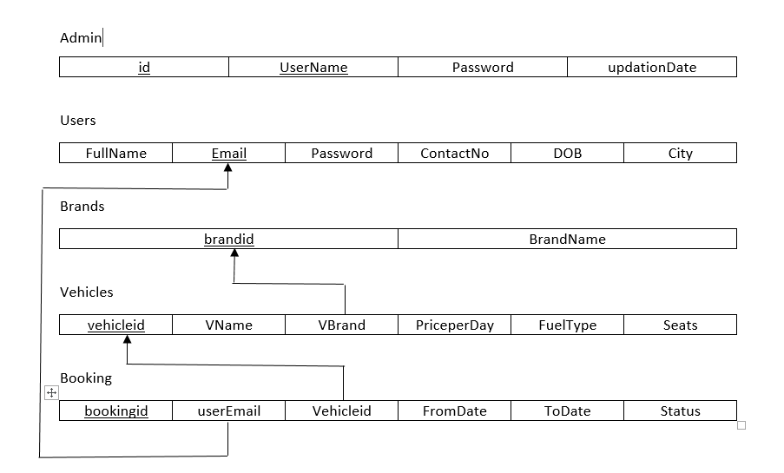

**Figure 2.1: Schema diagram**

Figure 2.1 shows the schema diagram of Car Rental Management system

|  |  |
| --- | --- |
| **2.2** | **ER DIAGRAM** |

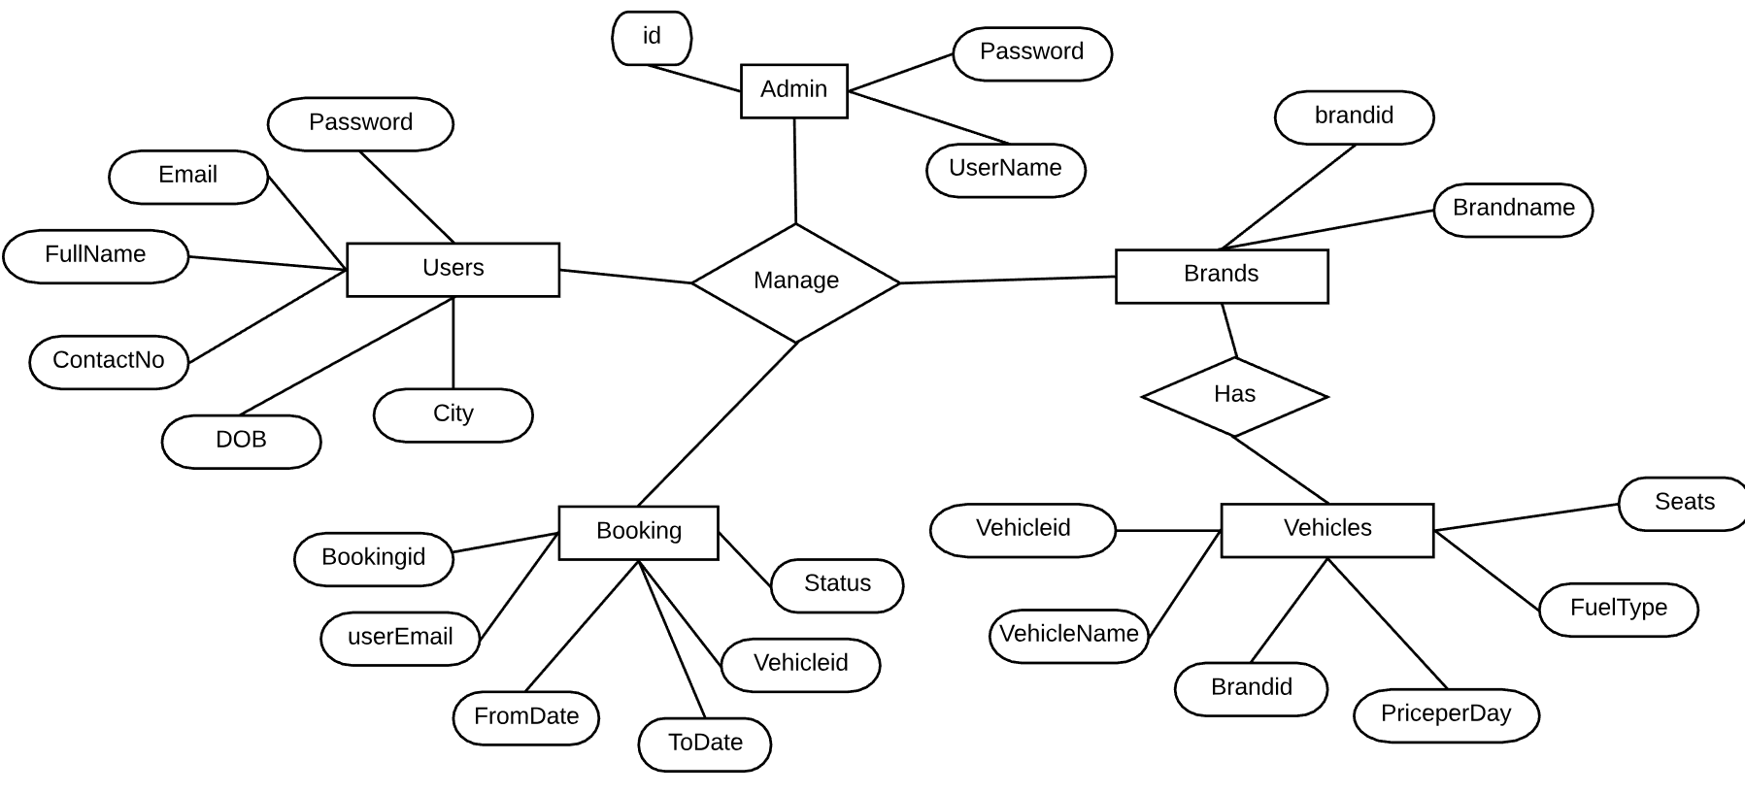

**Figure 2.2: ER diagram.**

Figure 2.2 shows the ER diagram of Car Rental Management system

**CHAPTER 3**

**IMPLEMENTATION**

**3.1 LANGUAGE USED FOR IMPLEMENTATION**

The languages used for implementation is as follows

* Front end:- PHP,HTML,CSS,JS
* Back end:- MySQL

**3.1.1 PHP** [1]

PHPis a [server-side scripting](https://en.wikipedia.org/wiki/Server-side_scripting) language designed primarily for [web development](https://en.wikipedia.org/wiki/Web_development) but also used as a [general-purpose programming language](https://en.wikipedia.org/wiki/General-purpose_programming_language). Originally created by [Rasmus Lerdorf](https://en.wikipedia.org/wiki/Rasmus_Lerdorf) in 1994, the PHP [reference implementation](https://en.wikipedia.org/wiki/Reference_implementation) is now produced by The PHP Development Team. PHP originally stood for Personal Home Page, but it now stands for the [recursive acronym](https://en.wikipedia.org/wiki/Recursive_acronym).

PHP code may be embedded into [HTML](https://en.wikipedia.org/wiki/HTML) or HTML5 [mark up](https://en.wikipedia.org/wiki/Markup_language), or it can be used in combination with various [web template systems](https://en.wikipedia.org/wiki/Web_template_system), [web content management systems](https://en.wikipedia.org/wiki/Web_content_management_system) and [web frameworks](https://en.wikipedia.org/wiki/Web_framework). PHP code is usually processed by a PHP [interpreter](https://en.wikipedia.org/wiki/Interpreter_(computing)) implemented as a [module](https://en.wikipedia.org/wiki/Plugin_(computing)) in the web server or as a [Common Gateway Interface](https://en.wikipedia.org/wiki/Common_Gateway_Interface) (CGI) [executable](https://en.wikipedia.org/wiki/Executable). The [web server](https://en.wikipedia.org/wiki/Web_server) software combines the results of the interpreted and executed PHP code, which may be any type of data, including images, with the generated [web page](https://en.wikipedia.org/wiki/Web_page). PHP code may also be executed with a [command-line interface](https://en.wikipedia.org/wiki/Command-line_interface) (CLI) and can be used to implement [standalone](https://en.wikipedia.org/wiki/Computer_software) [graphical applications](https://en.wikipedia.org/wiki/Graphical_user_interface).

**3.1.2 HTML** [2]

Hypertext Mark-up Language (HTML) is the standard [mark-up language](https://en.wikipedia.org/wiki/Markup_language) for creating [web pages](https://en.wikipedia.org/wiki/Web_page) and [web applications](https://en.wikipedia.org/wiki/Web_application). With [Cascading Style Sheets](https://en.wikipedia.org/wiki/Cascading_Style_Sheets) (CSS) and [JavaScript](https://en.wikipedia.org/wiki/JavaScript) it forms a triad of cornerstone technologies for the [World Wide Web](https://en.wikipedia.org/wiki/World_Wide_Web). [Web browsers](https://en.wikipedia.org/wiki/Web_browser) receive HTML documents from a [web server](https://en.wikipedia.org/wiki/Web_server) or from local storage and render them into multimedia web pages. HTML describes the structure of a web page [semantically](https://en.wikipedia.org/wiki/Semantic_Web) and originally included cues for the appearance of the document.

**3.1.3 MySQL** [3]

MySQL is an [open-source](https://en.wikipedia.org/wiki/Open-source) [relational database management system](https://en.wikipedia.org/wiki/Relational_database_management_system) (RDBMS). Its name is a combination of "My", the name of co-founder [Michael Widenius](https://en.wikipedia.org/wiki/Michael_Widenius)‘s daughter, and "[SQL](https://en.wikipedia.org/wiki/SQL)", the abbreviation for [Structured Query Language](https://en.wikipedia.org/wiki/Structured_Query_Language). The MySQL development project has made its [source code](https://en.wikipedia.org/wiki/Source_code) available under the terms of the [GNU General Public License](https://en.wikipedia.org/wiki/GNU_General_Public_License), as well as under a variety of [proprietary](https://en.wikipedia.org/wiki/Proprietary_software) agreements. MySQL was owned and sponsored by a single [for-profit](https://en.wikipedia.org/wiki/Business) firm, the [Swedish](https://en.wikipedia.org/wiki/Sweden) company [MySQL AB](https://en.wikipedia.org/wiki/MySQL_AB), now owned by [Oracle Corporation](https://en.wikipedia.org/wiki/Oracle_Corporation). For proprietary use, several paid editions are available, and offer additional functionality.

**3.2 PLATFORM USED FOR IMPLEMENTATION**

**3.2.1 XAMPP** [4]

XAMPPis a [free and open source](https://en.wikipedia.org/wiki/Free_software) [cross-platform](https://en.wikipedia.org/wiki/Cross-platform) [web server](https://en.wikipedia.org/wiki/Web_server) [solution stack](https://en.wikipedia.org/wiki/Solution_stack) package developed by Apache Friends, consisting mainly of the [Apache HTTP Server](https://en.wikipedia.org/wiki/Apache_HTTP_Server), [MariaDB](https://en.wikipedia.org/wiki/MariaDB) [database](https://en.wikipedia.org/wiki/Database), and [interpreters](https://en.wikipedia.org/wiki/Interpreter_(computing)) for scripts written in the [PHP](https://en.wikipedia.org/wiki/PHP) and [Perl](https://en.wikipedia.org/wiki/Perl) [programming languages](https://en.wikipedia.org/wiki/Programming_language). XAMPP stands for Cross-Platform (X), Apache (A), MariaDB (M), PHP (P) and Perl (P). It is a simple, lightweight Apache distribution that makes it extremely easy for developers to create a local web server for testing and deployment purposes. Everything needed to set up a web server – server application (Apache), database (MariaDB), and scripting language (PHP) – is included in an extractable file. XAMPP is also cross-platform, which means it works equally well on Linux, Mac and Windows. Since most actual web server deployments use the same components as XAMPP, it makes transitioning from a local test server to a live server extremely easy as well.

* + 1. **PhpMyAdmin**

PhpMyAdmin is a [free and open source](https://en.wikipedia.org/wiki/Free_and_open_source) administration tool for [MySQL](https://en.wikipedia.org/wiki/MySQL) and [MariaDB](https://en.wikipedia.org/wiki/MariaDB). As a portable [web application](https://en.wikipedia.org/wiki/Web_application) written primarily in [PHP](https://en.wikipedia.org/wiki/PHP), it has become one of the most popular MySQL administration tools, especially for [web hosting services](https://en.wikipedia.org/wiki/Web_hosting_service).

**3.3 SQL COMMANDS AND QUERIES**

In this system we used nine tables admin, booking, booking_backup, vehicles, brands, contactusquery and contactusinfo. The queries used for creating these tables as follows

**3.3.1 Admin details**

CREATE TABLE IF NOT EXISTS `admin` (

`id` int(11) NOT NULL,

`UserName` varchar(100) NOT NULL,

`Password` varchar(100) NOT NULL,

`updationDate` timestamp NOT NULL DEFAULT '0000-00-00 00:00:00' ON UPDATE CURRENT_TIMESTAMP

) ;

**3.3.2 Booking details**

CREATE TABLE IF NOT EXISTS `booking` (

`id` int(11) NOT NULL,

`userEmail` varchar(100) DEFAULT NULL,

`VehicleId` int(11) DEFAULT NULL,

`FromDate` varchar(20) DEFAULT NULL,

`ToDate` varchar(20) DEFAULT NULL,

`message` varchar(255) DEFAULT NULL,

`Status` int(11) DEFAULT NULL,

`PostingDate` timestamp NOT NULL DEFAULT CURRENT_TIMESTAMP

);

* + 1. **Brands details**

CREATE TABLE IF NOT EXISTS `brands` (

`id` int(11) NOT NULL,

`BrandName` varchar(120) NOT NULL,

`CreationDate` timestamp NULL DEFAULT CURRENT_TIMESTAMP,

`UpdationDate` timestamp NULL DEFAULT NULL ON UPDATE CURRENT_TIMESTAMP

);

* + 1. **Pages details**

CREATE TABLE IF NOT EXISTS `pages` (

`id` int(11) NOT NULL,

`PageName` varchar(255) DEFAULT NULL,

`type` varchar(255) NOT NULL DEFAULT '',

`detail` longtext NOT NULL

);

* + 1. **Users details**

CREATE TABLE IF NOT EXISTS `users` (

`id` int(11) NOT NULL,

`FullName` varchar(120) DEFAULT NULL,

`EmailId` varchar(100) DEFAULT NULL,

`Password` varchar(100) DEFAULT NULL,

`ContactNo` char(11) DEFAULT NULL,

`dob` varchar(100) DEFAULT NULL,

`Address` varchar(255) DEFAULT NULL,

`City` varchar(100) DEFAULT NULL,

`Country` varchar(100) DEFAULT NULL,

`RegDate` timestamp NULL DEFAULT CURRENT_TIMESTAMP,

`UpdationDate` timestamp NULL DEFAULT NULL ON UPDATE CURRENT_TIMESTAMP

);

**3.3.6 Create & Check connection**

define('DB_HOST','localhost');

define('DB_USER','root');

define('DB_PASS','kashi');

define('DB_NAME','carrental');

try

{

$dbh = new PDO("mysql:host=".DB_HOST.";dbname=".DB_NAME,DB_USER, DB_PASS,array(PDO::MYSQL_ATTR_INIT_COMMAND => "SET NAMES 'utf8'"));

}

catch (PDOException $e)

{

exit("Error: " . $e->getMessage());

}

**3.3.7 Triggers**

**After Insert**

DROP TRIGGER IF EXISTS `after_booking_insert`;CREATE DEFINER=`root`@`localhost` TRIGGER `after_booking_insert` AFTER INSERT ON `booking` FOR EACH ROW BEGIN INSERT INTO booking_backup VALUES(NEW.id,NEW.userEmail,NEW.VehicleId,NEW.FromDate,NEW.ToDate,NEW.message,NEW.Status,NEW.PostingDate); END

**After Update**

DROP TRIGGER IF EXISTS `after_booking_update`;CREATE DEFINER=`root`@`localhost` TRIGGER `after_booking_update` AFTER UPDATE ON `booking` FOR EACH ROW BEGIN UPDATE booking_backup set Status=1 WHERE id=NEW.id; END

**3.4 OUTPUT TESTING**

During the testing of our project we have to face different types of errors. Especially, database errors annoyed us but at last we solved it, successfully. Since a system is useful if it does not produce the required output in the specific format required by them tests the output generator displayed on the system under consideration. The output format on the screen is found to be correct as the format was designed in the system design phase according to the user needs.

**CHAPTER 4**

**RESULTS**

**4.1 SNAPSHOTS**

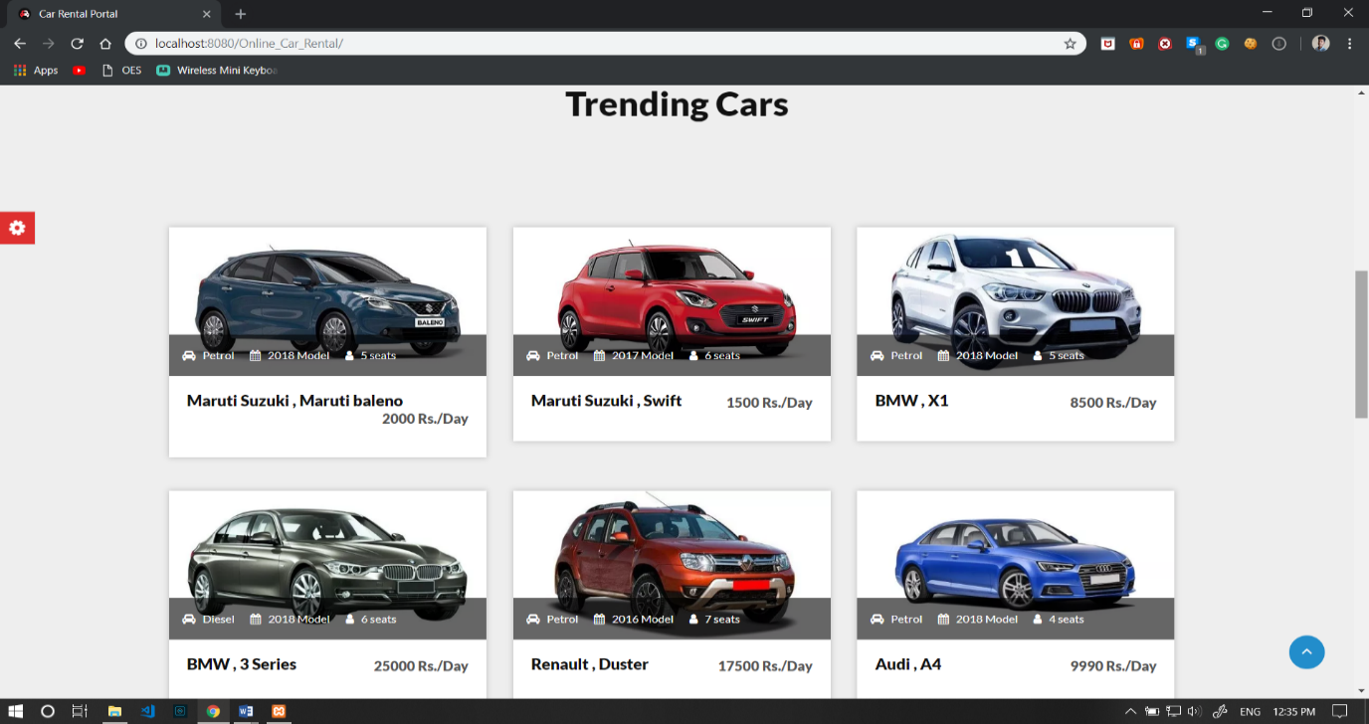

**Figure 4.1 Snapshot of Trending Cars**

In this system Home page Figure 4.1 will give the details of the trending cars for the Booking.

|  |  |  |
| --- | --- | --- |
|  |  |  |

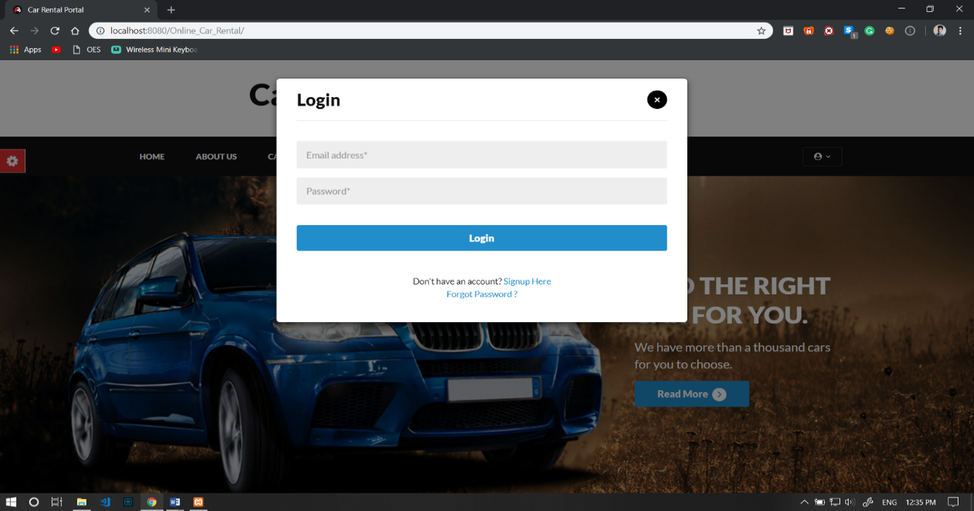

**Figure 4.2 Snapshot of Login Page**

The Figure 4.2 shows the snapshot of login page for Car Rental database system here we can log in to the Car Rental database system by giving the username and password.

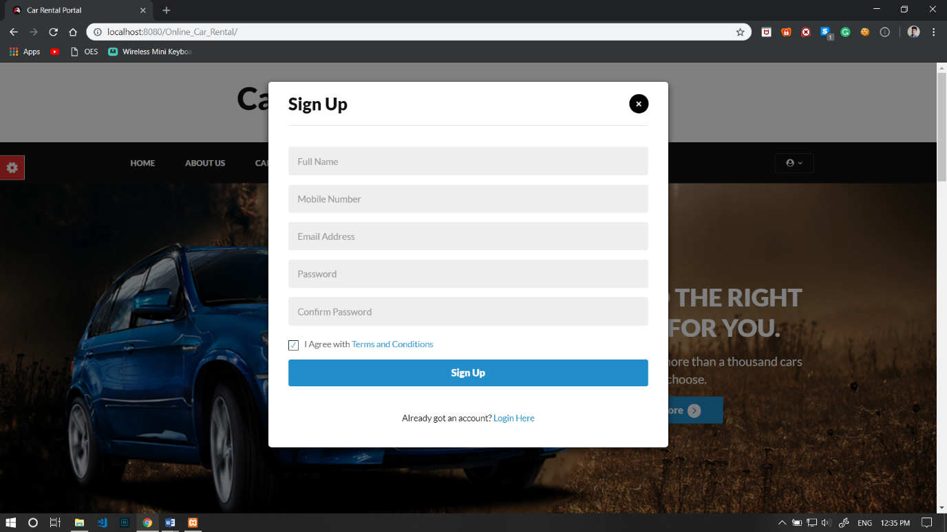

**Figure 4.3 Snapshot of Sign Up details**

The Figure 4.3 shows the Registration of new Use, Here we can add the user details.

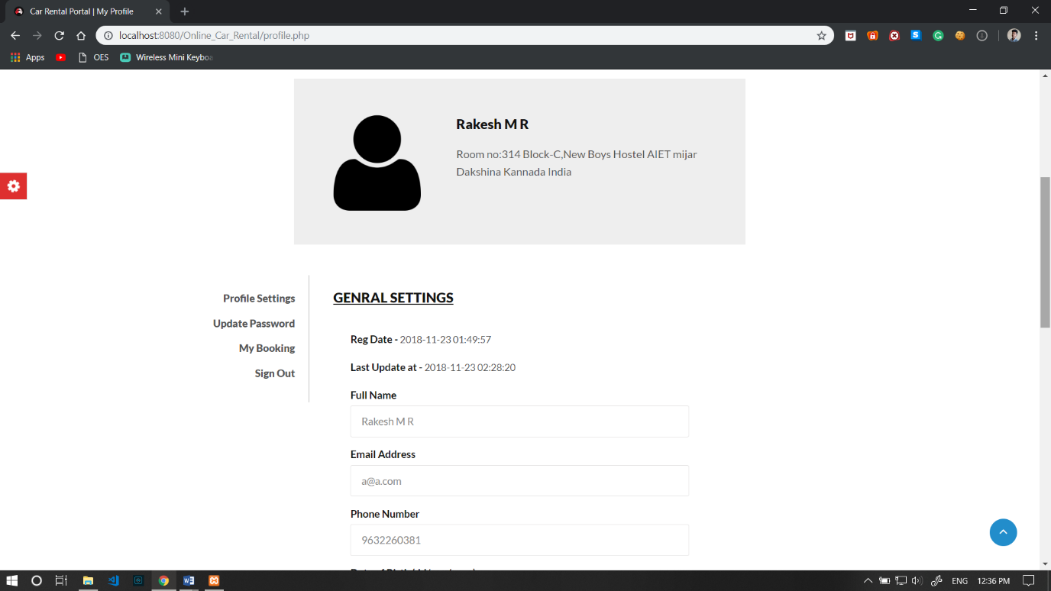

**Figure 4.4 Snapshot of User details**

The Figure 4.4 shows the snapshot of user Profile details, here we can update the user details.

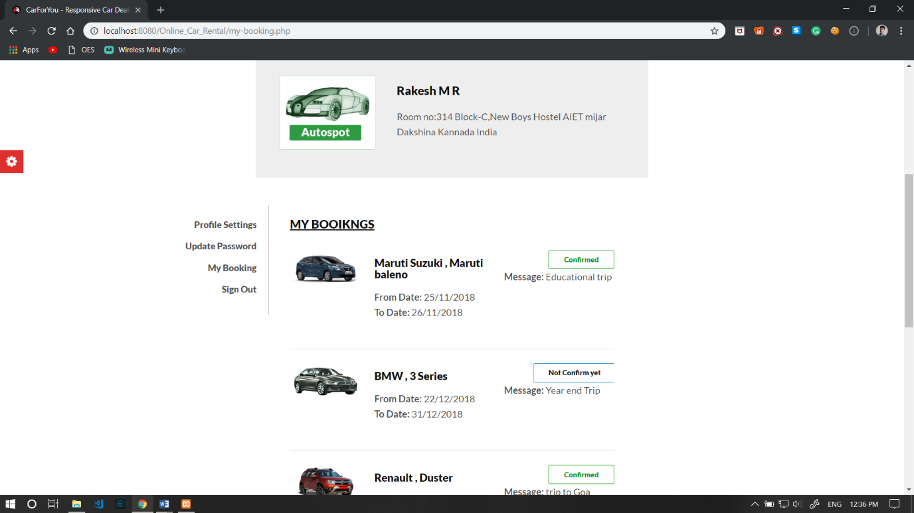

**Figure 4.5 Snapshot of booking details**

The Figure 4.5 shows the snapshot of User Booking details.

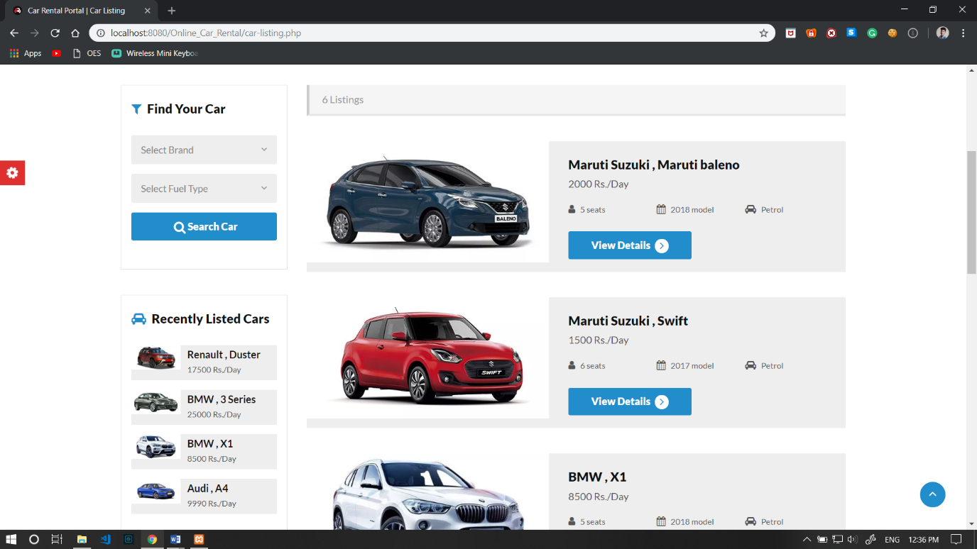

**Figure 4.6 List of Vehicles**

The Figure 4.6 shows the snapshot of all Car details, here we can book the car.

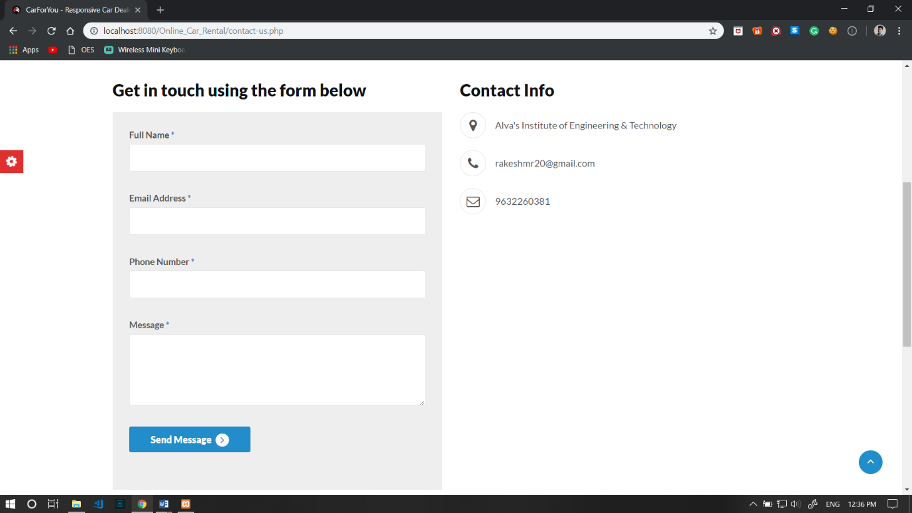

**Figure 4.7 Contact us Details & Query**

The contact info and registering the query is shown in Figure 4.7

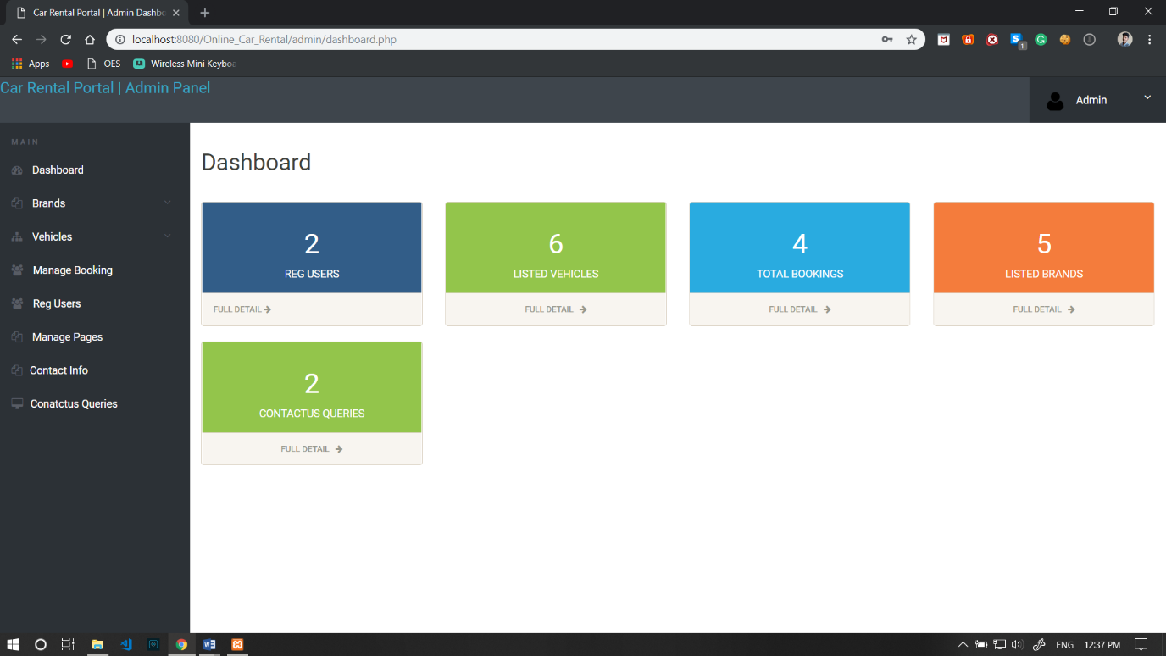

**Figure 4.8 Admin Dashboard**

In Figure 4.8 Admin Dashboard is shown.

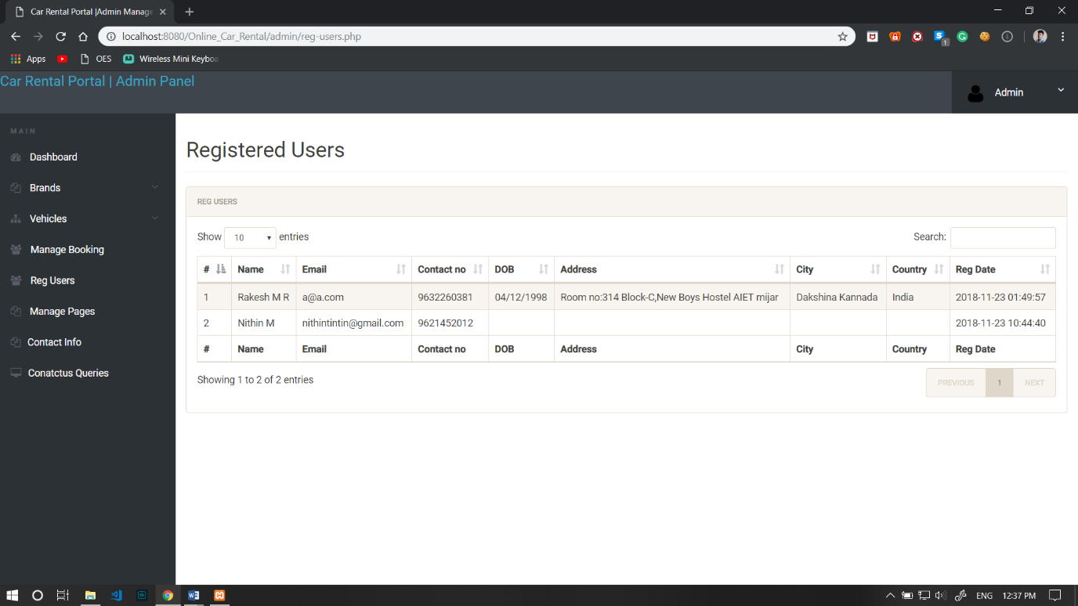

**Figure 4.9 List of Users**

In Figure 4.9 the list of registered users is displayed**.**

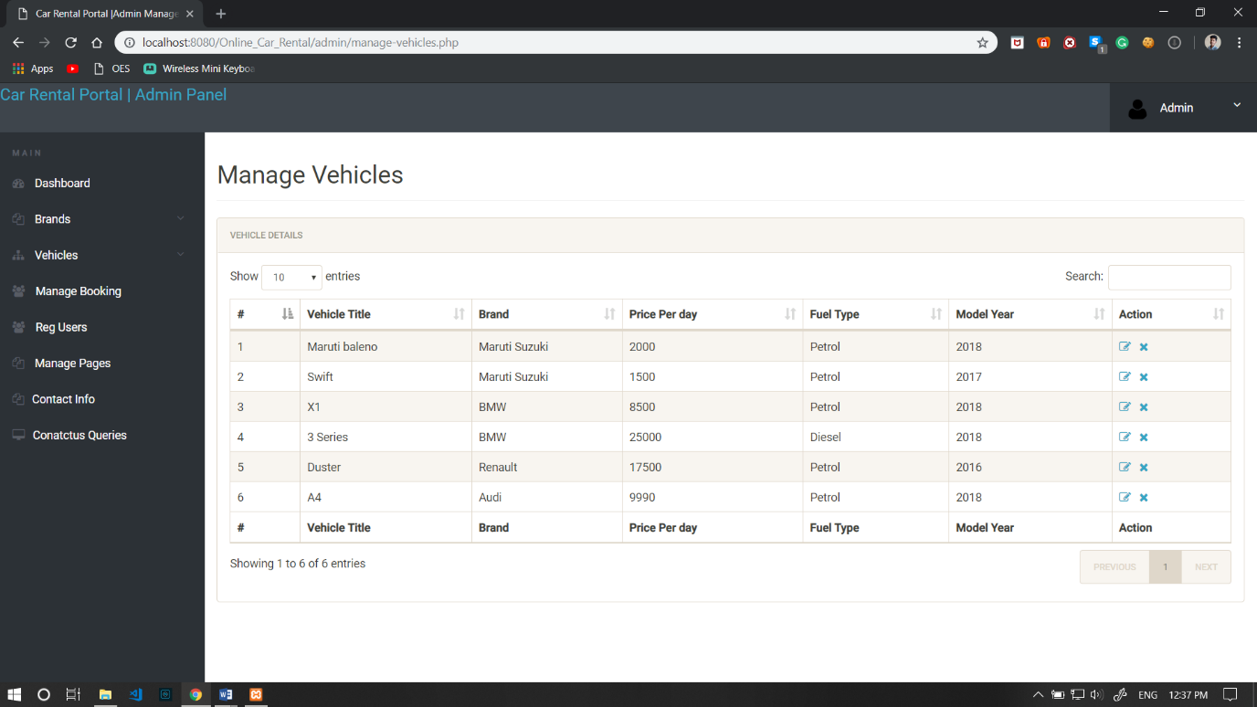

**Figure 4.10 Manage Vehicles**

The Figure 4.10 shows the different vehicles in database.

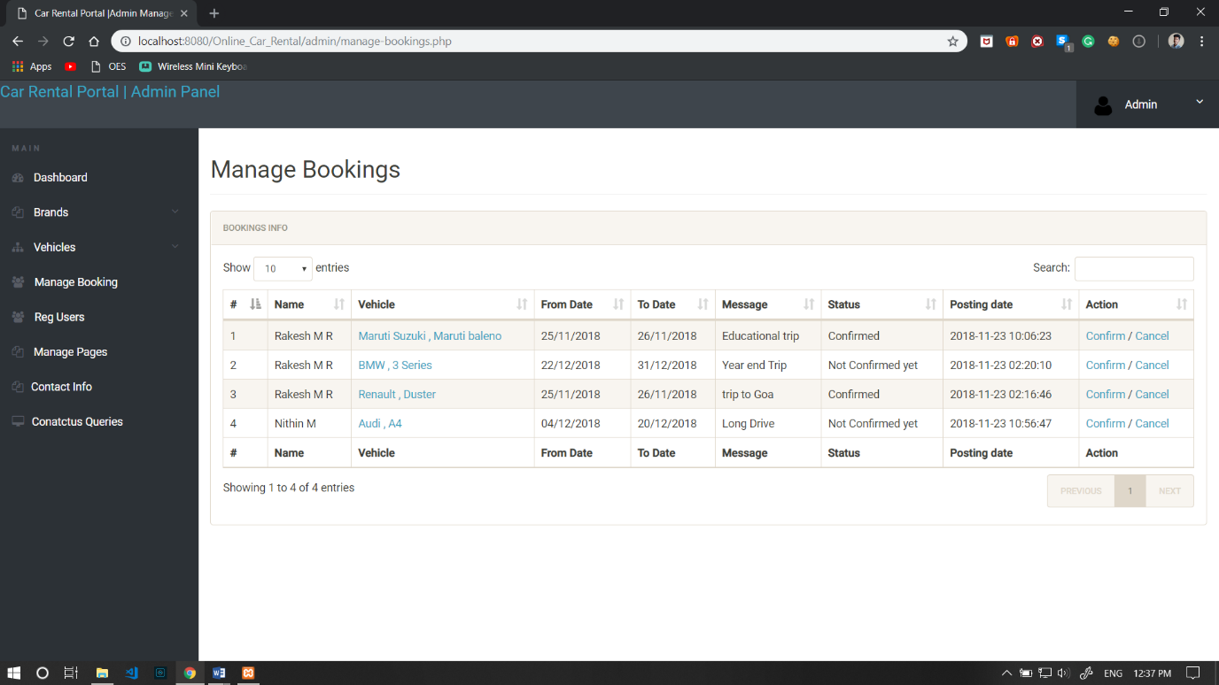

**Figure 4.11 Manage Bookings**

The Figure 4.11 shows all the bookings to the admin.

**CHAPTER 5**

**CONCLUSION AND FUTURE ENHANCEMENT**

**5.1 CONCLUSION**

Car Booking Services is a Web application and it is restricted to only limited type of users. In this application, Different types of managers have been given access rights and they are restricted up to their functionalities, so that the data is maintained securely and redundant data is prevented. As the Data is stored electronically, it is necessary to have a Computer and Network connection to access the Application. Here the Details of Employees and Drivers, cabs are maintained but accounts to these people are not created. Using this application mangers do assign or update the batch, shift of cabs to drivers and employees. But employees are unable to view their details.

.

**5.2 FUTURE ENHANCEMENT**

Every Edition of a book comes with new topics and modifications if any errors are present. In the similar way, in near future, our application will overcome the flaws if occurred, and attains new features offered to employees for the Flexible and easy Transportation. Following are the Enhancements to the application.

1. Providing Good User Interface.
2. Providing access permissions to the employees.
3. Try to Implement the GPS system in the Cars.
4. More Secure online secure Payments.

**REFERENCES**

[1]. PHP: Hypertext Preprocessor is a server-side scripting language designed for Web development, and also used as a general-purpose programming language.

[2]. HTML: Hypertext Markup Language is the standard markup language for creating web pages and web applications. With Cascading Style Sheets and JavaScript, it forms a triad of cornerstone technologies for the World Wide Web.

[3]. MYSQL: it is an open source relational database management system.

[4]. XAMPP: it is a free and open-source cross-platform web server solution stack package developed by Apache Friends, consisting mainly of the Apache HTTP Server, MariaDB database, and interpreters for scripts written in the PHP and Perl programming languages.

[5]. Car Details: https://www.carwale.com/new/